Curved Lateral Surface of a cylinder
# Source: AI Source: Provided by: [Data Path: Persons Table -> ID Column: 1, Name_En Column: Motasem Essam] -> From: [ChatGPT] on [7/25/2026]

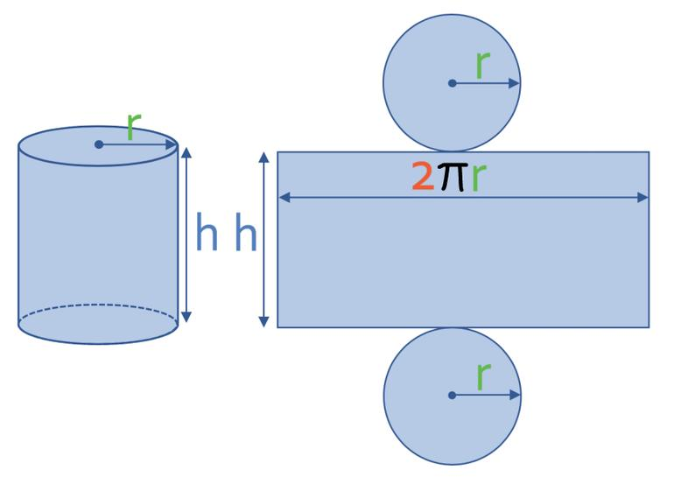
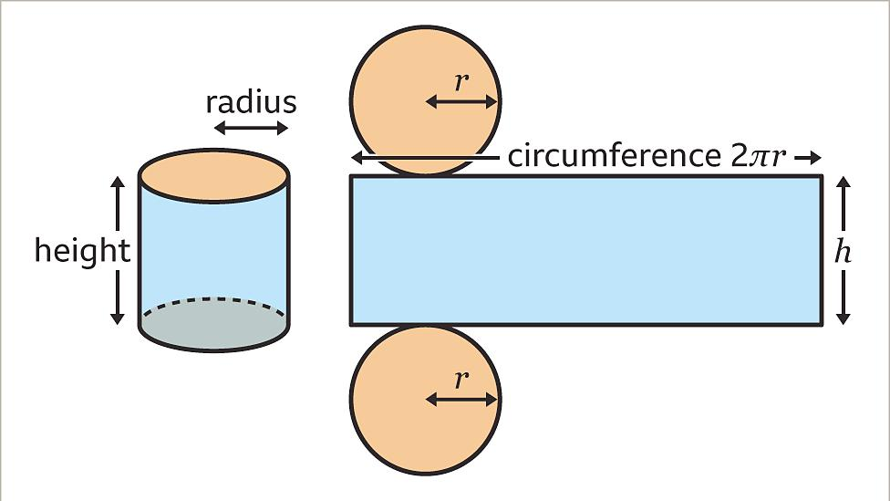
7

Definition
# Source: AI Source: Provided by: [Data Path: Persons Table -> ID Column: 1, Name_En Column: Motasem Essam] -> From: [ChatGPT] on [7/25/2026]
The curved lateral surface of a cylinder is the curved outer surface connecting the top and bottom bases of the cylinder. It surrounds the cylinder between its two bases and does not include either flat base.
In a right circular cylinder, this surface wraps around the circular bases. When unrolled, it forms a rectangle whose height equals the cylinder's height and whose width equals the circumference of a base.

Simple Definition
# Source: AI Source: Provided by: [Data Path: Persons Table -> ID Column: 1, Name_En Column: Motasem Essam] -> From: [ChatGPT] on [7/25/2026]
The curved lateral surface is the side of a cylinder, excluding its top and bottom circular faces.
For example, the side of a tin can is its curved lateral surface, while its lid and bottom are the bases.

Geometric Representation and Components
# Source: AI Source: Provided by: [Data Path: Persons Table -> ID Column: 1, Name_En Column: Motasem Essam] -> From: [ChatGPT] on [7/25/2026]
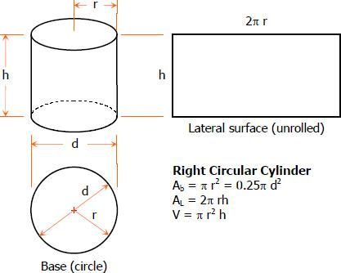
The curved lateral surface is associated with these elements:
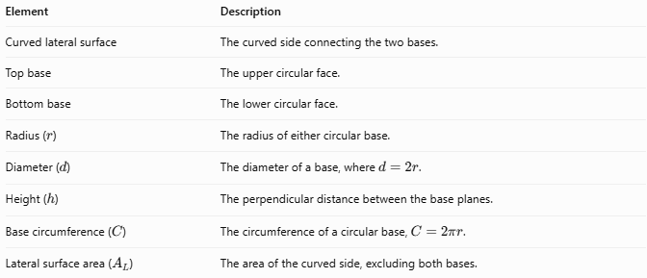
Element | Description
Curved lateral surface | The curved side connecting the two bases.
Top base | The upper circular face.
Bottom base | The lower circular face.
Radius ($r$) | The radius of either circular base.
Diameter ($d$) | The diameter of a base, where \(d=2r\).
Height ($h$) | The perpendicular distance between the base planes.
Base circumference ($C$) | The circumference of a circular base, $C=2πr$.
Lateral surface area ($A_{L}$) | The area of the curved side, excluding both bases.

Mathematical Formulas

Lateral Surface Area of a Right Circular Cylinder
# Source: AI Source: Provided by: [Data Path: Persons Table -> ID Column: 1, Name_En Column: Motasem Essam] -> From: [ChatGPT] on [7/25/2026]
The formula is:
$$\boxed{A_{L}=2πrh}$$
Where:
- $A_{L}$ = curved lateral surface area
- $r$ = radius of the circular base
- $h$ = perpendicular height of the cylinder
- $π≈3.14159$
Using the diameter $d=2r$, the formula can also be written as:
$$\boxed{A_{L}=πdh}$$

Derivation Using the Unrolled Surface
# Source: AI Source: Provided by: [Data Path: Persons Table -> ID Column: 1, Name_En Column: Motasem Essam] -> From: [ChatGPT] on [7/25/2026]
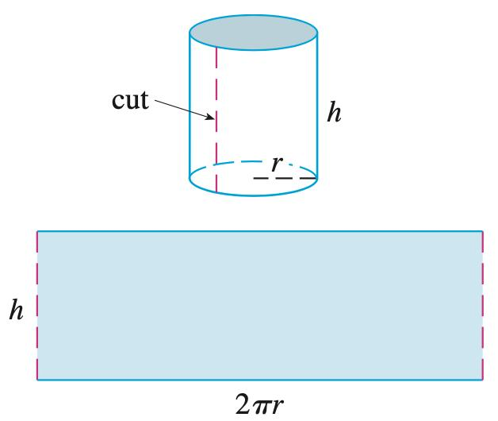
When the curved lateral surface of a right circular cylinder is unrolled, it forms a rectangle.
$$A_{L}=\text{width}×\text{height}$$
The rectangle's width equals the base circumference:
$$C=2πr$$
Its height equals the cylinder's height:
$$A_{L}=C×h$$
Therefore:
$$\boxed{A_{L}=2πrh}$$

Related Formulas
# Source: AI Source: Provided by: [Data Path: Persons Table -> ID Column: 1, Name_En Column: Motasem Essam] -> From: [ChatGPT] on [7/25/2026]
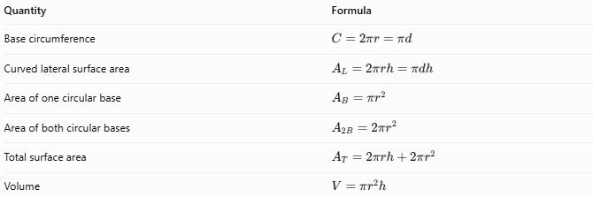
Quantity | Formula
Base circumference | $$C=2πr=πd$$
Curved lateral surface area | $$A_{L}=2πrh=πdh$$
Area of one circular base | $$A_{B}=πr^{2}$$
Area of both circular bases | $$A_{2B}=2πr^{2}$$
Total surface area | $$A_{T}=2πrh+2πr^{2}$$
Volume | $$V=πr^{2}h$$
Important: Lateral surface area measures only the curved side. Total surface area includes the curved side and both circular bases.

Worked Examples
# Source: AI Source: Provided by: [Data Path: Persons Table -> ID Column: 1, Name_En Column: Motasem Essam] -> From: [ChatGPT] on [7/25/2026]
Example 1 — Calculate the Lateral Surface Area Using the Radius
A right circular cylinder has a radius of $5\text{ cm}$ and a height of $12\text{ cm}$. Find its curved lateral surface area.
Given:
$$r=5\text{ cm}, h=12\text{ cm}$$
Solution:
$$A_{L}=2πrh$$
$$A_{L}=2π\left(5\right)\left(12\right)$$
$$\boxed{A_{L}=120π{\text{ cm}}^{2}}$$
Approximately:
$$\boxed{A_{L}≈376.99{\text{ cm}}^{2}}$$
Example 2 — Calculate the Lateral Surface Area Using the Diameter
A right circular cylinder has a diameter of $8\text{ m}$ and a height of $10\text{ m}$. Find its curved lateral surface area.
Given:
$$d=8\text{ m}, h=10\text{ m}$$
Solution:
$$A_{L}=πdh$$
$$A_{L}=π\left(8\right)\left(10\right)$$
$$\boxed{A_{L}=80π{\text{ m}}^{2}}$$
Approximately:
$$\boxed{A_{L}≈251.33{\text{ m}}^{2}}$$
Example 3 — Find the Height from the Lateral Surface Area
A right circular cylinder has a radius of $4\text{ cm}$ and a curved lateral surface area of $160π{\text{ cm}}^{2}$. Find its height.
Given:
$$A_{L}=160π{\text{ cm}}^{2}, r=4\text{ cm}$$
Start with:
$$A_{L}=2πrh$$
Rearrange to solve for $h$:
$$h=\frac{A_{L}}{2πr}$$
Substitute:
$$h=\frac{160π}{2π\left(4\right)}=\frac{160π}{8π}$$
$$\boxed{h=20\text{ cm}}$$

Comparison with Related Cylinder Surfaces
# Source: AI Source: Provided by: [Data Path: Persons Table -> ID Column: 1, Name_En Column: Motasem Essam] -> From: [ChatGPT] on [7/25/2026]
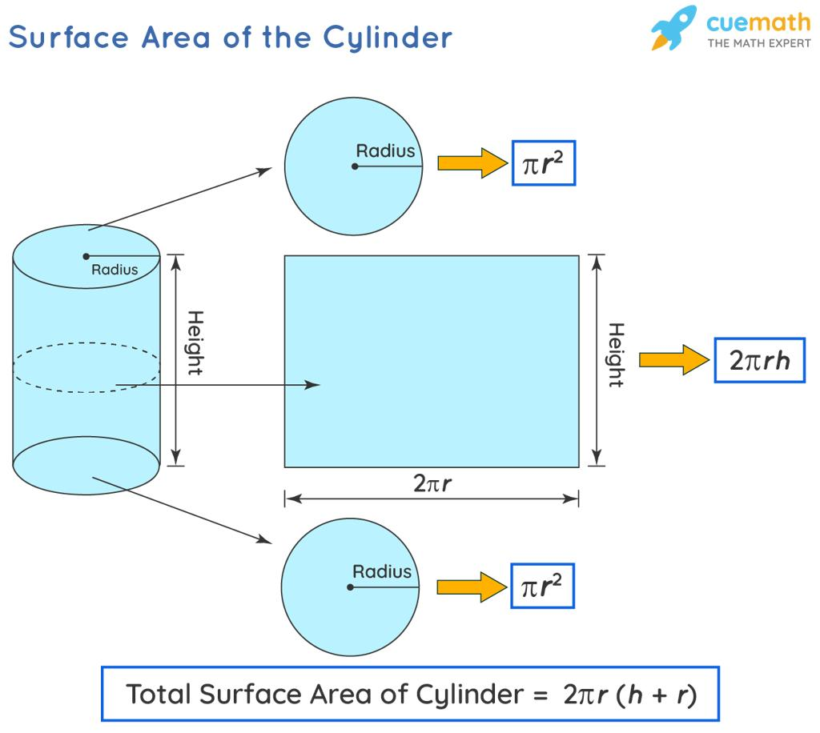
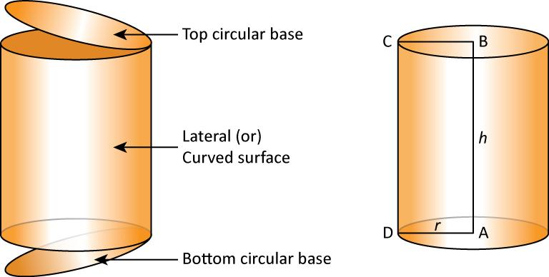
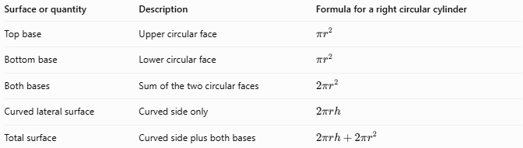
Surface or quantity | Description | Formula for a right circular cylinder
Top base | Upper circular face | $$πr^{2}$$
Bottom base | Lower circular face | $$πr^{2}$$
Both bases | Sum of the two circular faces | $$2πr^{2}$$
Curved lateral surface | Curved side only | $$2πrh$$
Total surface | Curved side plus both bases | $$2πrh+2πr^{2}$$

Applications
# Source: AI Source: Provided by: [Data Path: Persons Table -> ID Column: 1, Name_En Column: Motasem Essam] -> From: [ChatGPT] on [7/25/2026]
The curved lateral surface area is useful for calculating the amount of material needed to cover the sides of cylindrical objects.
- Cans and containers: estimating labels or side coverings.
- Pipes and ducts: estimating the outer material covering a straight cylindrical section.
- Cylindrical tanks: estimating the material required for the side wall, excluding the top and bottom.
- Columns and pillars: calculating the area to paint or coat.
- Packaging: determining the size of a rectangular sheet that wraps around a cylindrical object.
For practical material estimates, additional material may be needed for overlaps, seams, cutting, or waste.

Key Points
# Source: AI Source: Provided by: [Data Path: Persons Table -> ID Column: 1, Name_En Column: Motasem Essam] -> From: [ChatGPT] on [7/25/2026]
- The curved lateral surface is the side of a cylinder, excluding its two bases.
- For a right circular cylinder, $A_{L}=2πrh$.
- The equivalent diameter formula is $A_{L}=πdh$.
- Unrolling the lateral surface of a right circular cylinder produces a rectangle.
- Surface area is measured in square units, such as ${\text{cm}}^{2}$ or ${\text{m}}^{2}$.
- The formula $2πrh$ uses the perpendicular height and applies directly to a right circular cylinder; an oblique cylinder requires additional geometric information.

Conclusion
# Source: AI Source: Provided by: [Data Path: Persons Table -> ID Column: 1, Name_En Column: Motasem Essam] -> From: [ChatGPT] on [7/25/2026]
The curved lateral surface of a cylinder is the outer curved side connecting its two circular bases. For a right circular cylinder, its area is found by multiplying the circumference of the base by the height:
$$\boxed{A_{L}=2πrh}$$
Understanding this surface helps distinguish lateral surface area from the area of the bases and the total surface area.

